

**Name:** Jose I. Padovani

**Research Topic:** Electromagnetic Actuation on Digital Ferro-Microfluidic Devices for Label-free Rare Cell Detection and Isolation

**Motivation:**

Capture and detection of rare cells are most commonly based on immuno-mediated approaches followed by multi-spectral fluorescent-based assays. These techniques have several drawbacks: 1) Captured cells are subjected to significant stress during immobilized capture and fluorescent tagging resulting in decreased viability 2) Fluorescent-based assays are costly and time-consuming and 3) Low throughput.

**Goals:**

This project focuses on the design, fabrication, and integration of a label-free microfluidic system for detecting, capturing, and isolating rare cells within a water-in-ferrofluid droplet. Using our system, cells will be gently transported and efficiently isolated; ready for further study using emerging droplet-based PCR and sequencing technologies.

**Approach:**

Figure 1. a) Ferro-microfluidic device representation. Cells are inside the droplets with no contact to the surrounding ferrofluid. b) By applying a current to the coil, a magnetic field is generated and the droplets are repelled.



a)

b)

Droplets containing single cells of interest can be isolated from the flow and manipulated using magnetic digital microfluidic techniques. Magnetic fields have no impact over the cells since they neither induce charges nor affect the pH of the solution.

**Technology:**

Our system uses an electrode array (Figure 1), embedded within the device, to generate magnetic fields that actuate the oil-based ferrofluid medium, displacing the aqueous droplets in a process called *negative magnetophoresis* (Figure 2).



Figure 2. In a negative magnetophoresis system, a non-magnetic particle (droplet, white circle) inside magnetic medium (ferrofluid, black rectangle) experiences a repulsive force (Fm) with the same magnitude and opposite direction as a magnetic particle of the same volume due to the virtual magnetic dipole moment (red arrow). The viscous drag force (Fd) of the liquid will oppose to magnetic displacement.

**Simulations:**

Finite element analysis (COMSOL) is used to simulate the magnetic field (Figure 3) and calculate the magnetic body force imparted on the droplets. This method allows coupling of both the fluidic and the electromagnetic physics for a complete simulation and an accurate representation of the actual device behavior.



Figure 3. Finite element analysis of B-Field across the device.

**Fabrication:**

The device is fabricated in two parts. First, the coils are made by electroplating copper on a quartz substrate. Second, the microfluidic chip is made using conventional soft-lithography techniques on PDMS. Finally, both components are bonded together to complete the device (Figure 4).

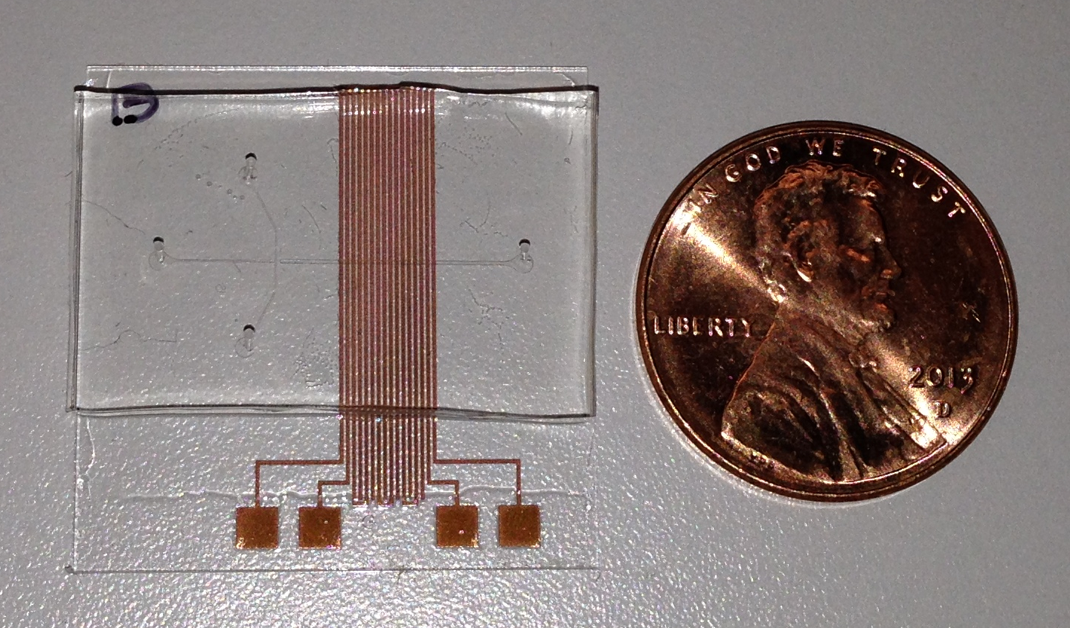

Figure 4. Picture of ferro-microfluidic device.

**Operating Modes:**

This versatile technology can be used for an array of different microfluidic applications, including some of the depicted below in Figures 5-7.

Figure 5. Linear transport. Sequential coil actuation achieves travelling magnetic wave.



Figure 6. Two-dimensional trapping for virtual array generation.



Figure 7. Fluorescent activated detection and electromagnetic droplet sorting.